MAINTENANCE METHODS

Method 1
Direct Access to the area
- Maintenance activity from the available gap
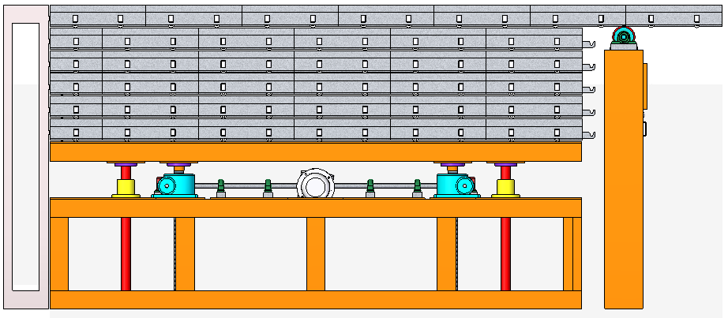

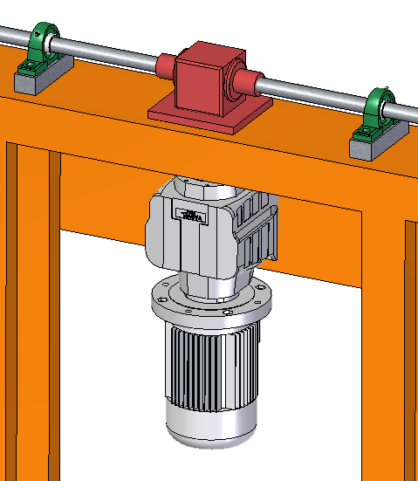
The pallet 1 of 4425mm x 5500mm. After stacking there is gap between the power roller unit and swimming pool parapet wall. The gap is around 400 mm in width and 5500 mm in length. We can manually dismantle pallet 1 partially and maintenance personnel can enter from the available cut out in the pit.
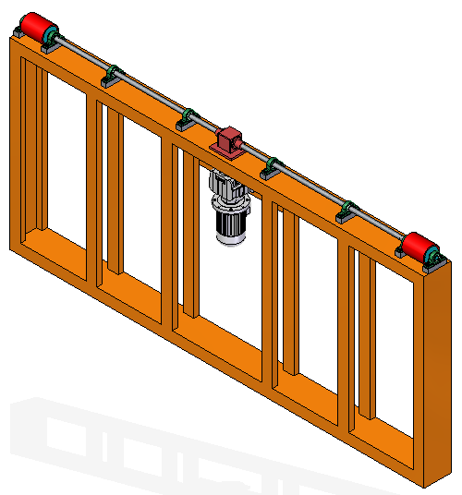
The area will give direct access to both the motors as well as lifter and slider mechanism for the maintenance purpose.

Method 2
Access to more area
- Removal of Power roller Unit
In case of maintenance while pallet stacking in the pit, for better space availability and accessibility, we can remove the whole power roller unit. From here we can have direct access to motors, lifter mechanism, slider mechanism, shafts, gearbox etc.
To achieve it, we need to design the power roller unit assembly in such a way that it slides along the pit depth so whole system act as a vertical slider in the pit. In the marked area, we can place the sliding mechanism if required so we can access the pit without any space constraint.
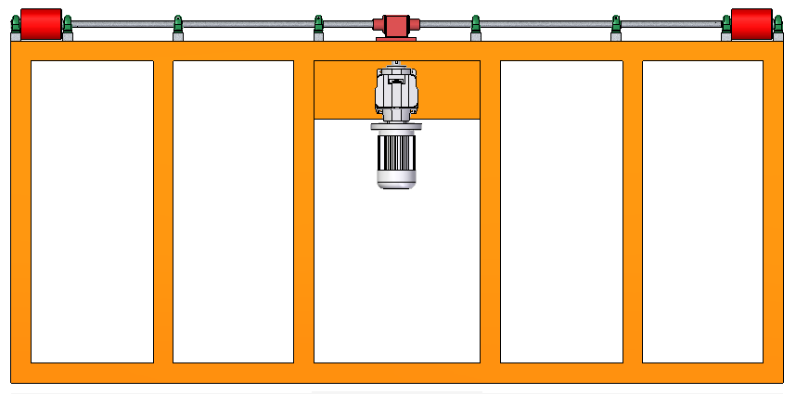

Method 3
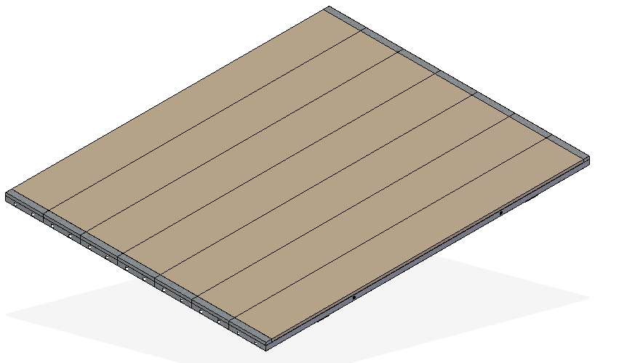
- Dismantling of Pallets
Piece 6
Piece 5
Piece 4
Piece 3
Piece 2
Piece 2
Piece 1

Another method that can be followed in case of breakdown is to dismantle all the Pallet from pallet 1 to 6. Each pallet is made in small members as shown below. They are bolted with each other and can be dismantled.
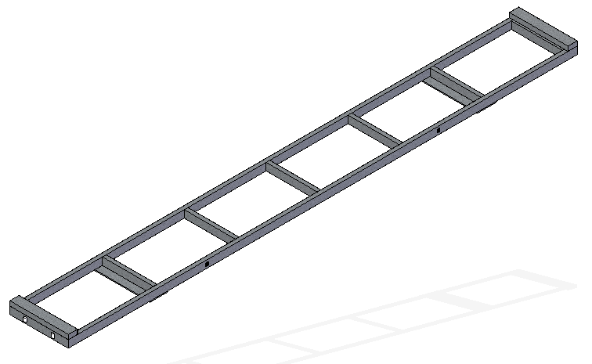
Each Piece Dimensions are – 5500mm x 750mm x 120mm approx. and Every 700mm distance we are going join another frame. So, it becomes easy to dismantle completely

Method 4
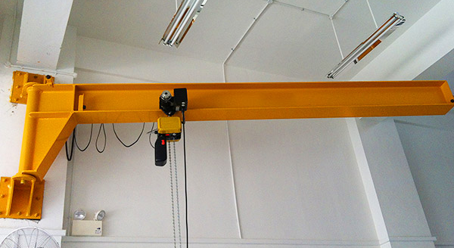
- Column mount Swing Hoist Crane

Other technique is to use column mount swing hoist crane. This system can be mounted on wall or column. We can fix a plate on wall and whenever it is required, we can mount the system on the wall in male female locking arrangement. Then it can be used to lift each pallet one by one from the pit unit.
We can easily shift pallet from 1 to 6 from the swing hoist crane. The capacity can be defined as per the weight of pallets. It not only reduces the human effort but also drastically reduces time of dismantling.
After the maintenance, we can again lift each unit again one by one and transfer it to pit. In this method, we don’t need to dismantle each pallet for maintenance purpose.

